**PALESTINE OLIVES**

**Reflections by Dimitri Araj, *a Palestinian living in Oxted. A member of Tatsfield Badminton Club for many years and a supporter of the Tatsfield Fairtrade Group, he wrote these reflections during a recent visit to his family in Bethlehem and nearby Beit Jala.***

**The olive is the natural king of trees in Palestine.** Olives are as bread and butter to Palestinians. In a good season, one bountiful tree will almost feed a family. The berries form a very nourishing and fatty food, especially in the hot season. Zeit wa Za’tar (bread dipped in olive oil and crushed wild thyme) is one of our most traditional foods.

The Mount of Olives is one of the most famous sites in Jerusalem and at its foot is the Garden of Gethsemane, where according to Christian tradition Jesus prayed and his disciples slept. In addition to its religious significance, a scientific study has shown that the olive trees in the garden are some of the oldest in the world - about 2,000 years old.

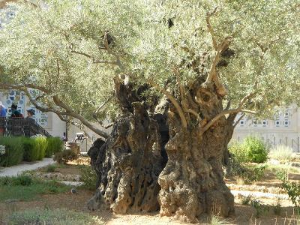**History, Religion, War and Peace:** According to Jewish and Christian teaching, during the great flood the dove sent in search of land by Noah returned with an olive leaf. In ancient Rome, the defeated during a war used to hold an olive branch pleading for peace. The olive branch became synonymous with peace.

**Ancient olive tree in the garden of Gethsemane**

***Palestine is the Holy Land****.* However, for the last 100 years there has been no peace in the land of love and peace! In 1917, Lord Balfour promised a Jewish homeland in Palestine ignoring Palestinian Arabs rights who had lived there for thousands of years. This has resulted in continuous conflict between Zionists on one side and Moslem and Christian Palestinians on the other. In addition to the struggle against British rule during the mandate government, fighting with the Zionists continued for generations. In 1948 after the British withdrawal, the Zionists won the war leading to what we call the ‘Nakba’ catastrophe and the creation of the State of Israel. This created today’s problem with over five million Palestinian refugees worldwide, mostly in camps, denied a right of return to their homes. Israel occupied over two thirds of Palestine and remaining areas of the West Bank were annexed to Jordan while the Gaza strip was placed under Egyptian administration.

In June1967 the Six Day War took place. Israel won the war easily and occupied the West Bank and Gaza thus controlling the whole of Palestine and resulting in another wave of Palestinian refugees. This time there was more awareness and resistance by the Palestinians and most Palestinians remained under occupation until now, one of the longest occupations in modern history. Successive Israeli governments encouraged and facilitated illegal settlements in the West Bank and parts of the Gaza strip. Over 600,000 settlers now live in over 200 illegal settlements in the West Bank.

Under the 1993 Oslo Accord, Israel and the Palestine Liberation Organization (PLO) agreed to bring lasting peace to the area but many of us Palestinians consider things were made much worse for us despite allowing some Palestinians from the PLO leadership to return and establish the Palestinian Authority. In fact, Israel still fully controls the whole territory, including even drinking water, with checkpoints and other harsh measures. This was capped by the construction of what we call “the apartheid wall of shame”, which is 650 km long and designed to grab as much Palestinian land as possible. In Bethlehem, the wall is between 10 and 12 metres high and has deprived us local residents of one third of our land and property. My family lost 11 acres of land at various locations, most of it planted with olives. This leaves us with just under six acres of land.

Zionist settlers deliberately destroy olive trees because of their symbolism for Palestinian life and identity. This year alone over 7,000 trees have been uprooted or burnt. In total, over half a million trees have been destroyed by Israel, changing the face and history of Palestine and depriving us of our national symbol and natural source of income.

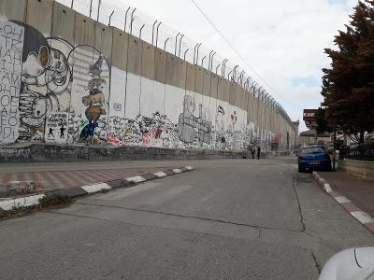There are also many documented incidents of settler gangs attacking Palestinian farmers to keep them away from their own land during the olive-picking season. Many Palestinian sympathisers from Europe and the UK visit Palestine to help in the olive picking season and protect local farmers by observing or even making a human shield against settlers.

**The Apartheid Wall in Bethlehem (this is 200 metres away from the Araj family home)**

**Olive Grove Farming / Local Practice:** In Palestine to this day, there are far more olive trees than any others, for it is essentially “a land of olive oil”. Trees in an olive yard often belong to various owners each with a small holding - sometimes even just a few trees. In some quarters the olive oil is known locally as “’the Green Gold”.

Until the mid-1960s, we used small stone mills to press olives - similar to a technique used for centuries. In 1966, my father, Judeh Araj, set up the first “Olive Press Cooperative for Bethlehem Area”. One of its priorities was to import olive pressing machines from Italy. That was a major achievement and almost doubled oil production and halved the queuing and waiting time for local farmers to one or one and a half days maximum waiting for their turn to press their produce.

Growing olive trees is a process that takes tens of years and generations. The age of local trees varies from a few years to hundreds of years. The older trees are called “Romaniat” as they originate from trees planted during the Roman Empire over 2,000 years ago and have a girth of over two metres.

Looking after an olive grove is a never-ending cyclical chore. January to April is the ploughing season. This is traditionally done by a ploughman guiding a plough pulled by a mule. Sometimes manure is added to the fields during ploughing to enrich the soil. Very few fields are accessible by tractors owing to the mountainous nature of the land and the small area of individual plots. Terraces separated by dry stone walls are a main and common feature. In the spring to summer months, it is time for weeding and keeping the fields clear from wild grass and invasive species. Grass left dries up from the very hot sun and can lead to wildfires.

Autumn is the busiest time: picking the olives, collecting and pressing them. Pruning the trees and getting rid of the spoil comes after that as well as pickling the olives for eating later. Spreading manure to enrich the soil is also done before winter.

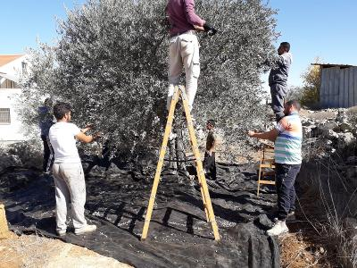The Ministry of Agriculture usually announces the start date of the olive-harvest - normally in October. The olive-picking season is an occasion when families gather round to collect the produce and to picnic. Two local families help my brother in this task because we cannot manage it on our own. They get half of the oil in return. The men and boys climb the trees using

***The last day of typical olive picking in Beit Jala (taken on 02/11/18)***

a stepladder. The olives

are picked by hand and

thrown to the ground

where sheets of tarpaulin or jute are normally placed around the tree. Women and children gather the olives from the ground and the low branches.

Every day sacks of olives are moved to the flat roof of our house and spread in heaps about 10 cm deep. This operation is repeated daily until the whole crop is in. This season it took three weeks to complete my family’s olive picking from the four locations that we own in and around my hometown, Beit Jala. Upon completion, the whole quantity is gathered and taken to the olive press. This year’s crop was just over two tons and produced about 750kgs of fresh oil. The cost of this barely covers the expenses that my family incurred during the year but it is worth it because it is our heritage, pride and joy.

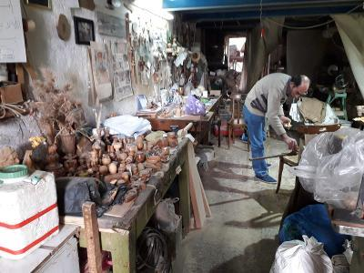The solid remains of olives, after pressing for oil, are called pomace. This contains the skins, pulp, seeds, and stems of the olive. At the Bethlehem cooperative, the pomace is processed to make briquettes for fuel, producing extra income. In other places and countries, pomace oil is produced and marketed as a lower quality oil for cooking or in cosmetics.

**Traditional Palestine handmade olive wood artisan workshop in Beit Jala**

After the olive harvest, the trees are pruned and excess growth trimmed back. Thin branches and leaves are used to feed goats or for open fires. The other branches are seasoned and the olive wood is used by local artisans to make artefacts and souvenirs for tourists and pilgrims. This is a local skill mainly restricted to the Bethlehem area.

**Fairtrade:** The Palestine Fairtrade Association (PFTA) is the largest fair-trade producers’ union in Palestine, with over 1,400 smaller Palestinian farms in Fairtrade collectives and cooperatives. Collectively the farmers produce the traditional olive oil and food delicacies, and export them to buyers and markets not available to an individual farmer. Fairtrade means social and economic empowerment – a dignified living for farmers who have not had access to the outside world for over 40 years. The PFTA revitalises farming traditions and a culture of sustainability by linking the traditionally organic farming methods of Palestine to modern organic/ecological movements and markets. Farming communities benefit from living wages paid to farmers and producers and from Fairtrade reinvestment in the community through the payment of social premiums to cooperatives. The cooperatives and collectives that are established along the production process serve as vital community organisations which can address other issues of common interest. Fairtrade cooperatives in Palestine bring back lost traditions, reintroduce a new spirit into village work ethics and renew social values and ties weakened by continuous conflict.

We all want the world to know that the simple act of buying a bottle of olive oil from PFTA’s exporters and distributors around the world such as Zaytoun, Canaan and PalTrade helps Palestinian families like ours survive and maintain the connection to our land and ancient olive trees.