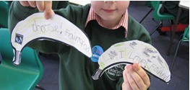
FAIRTRADE FESTIVAL AT TATSFIELD SCHOOL

On Tuesday 26 March I and six other Oxted School students went to Tatsfield Primary to assist in their Fairtrade Day as part of Fairtrade Fortnight. After a short but puddle-filled journey we unloaded lots of very large boxes filled with Fairtrade items from around the world from a very small car - the Fairtrade TARDIS - and made our way to the school. We had arrived just before break time so the halls were clear for us to set up the display of Fairtrade products from around the world. The items were arranged by country and continent: bracelets from Thailand, soapstone elephants from Kenya and a whole range of products from countries in South America, South East Asia and Africa. Moyna Bridge(owner of the Fairtrade TARDIS and display of Traidcraft goods) had performed the same trick with the boxes and crammed in so many things we struggled to fit them all on! Throughout the day, children from each class were taken to look around the display and listen to Moyna explaining where everything was from and the importance of Fairtrade.
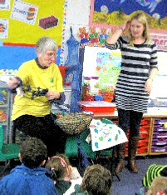
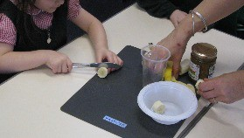
After finishing the display we split into groups and left for our separate classrooms. We worked with Key Stage 1(Reception to Year 2) for the first half of the day and I and another Oxted volunteer Alan- nah went to help Kingfisher class (Year 2). The children had had an assembly on Fairtrade the day beforeand clearly remembered it, naming Fairtrade foods and the purpose of Fairtrade. We made Fairtrade posters and decorated them with the Fairtrade logo, packets from Fairtrade foods and slogans such as ‘Support Farmers’, ‘Buy Fairtrade’ and ‘Stick with Foncho’ (a banana farmer from Colombia who is the face of 2014’s Fairtrade Fortnight). The children really enjoyed making the posters and finished the lesson by singing the Fairtrade Banana song they had learnt in the assembly. Other classes made banana smoothies and wrote persuasively on banana templates encouraging people to ‘Look for the Fairtrade sticker’. These became an impressive banana plant on display ion the reception area of the school.

After lunch, it was Key Stage 2’s turn. This time I went to Kestrel class (Year 4) to help them make Fairtrade banana bread. Again, the chil- dren knew a lot about Fairtrade and the banana bread was made with little difficulty- but a lot of mess! Other classes played the Orange game where children took on the role of Orange farm- ers and had to try and make a living against the efforts of money lenders who would charge huge rates of interest, the fluctuating price of oranges and the “livings collector” who collect- ed taxes at extortionate rates. The children really enjoyed the teamwork aspect and the game let them experience first-hand the need for Fairtrade.

At the end of the day parents and children were invited to buy items from the display. Prices ranged from 40p to £30 so there was something for everybody. Unsurprisingly, the Fairtrade chocolate was the most popular!

We’re very grateful to Mrs. Harber and Mrs. South for organising the event and hope that the children had as much fun learning about Fairtrade as we did helping.

Cecily Bateman, Year 10 student Oxted School

Oxted School is a Fairtrade school and this day at Tatsfield School was an example of some of their students playing their part in promoting Fairtrade.

