IS ALL FAIRTRADE COFFEE THE SAME?

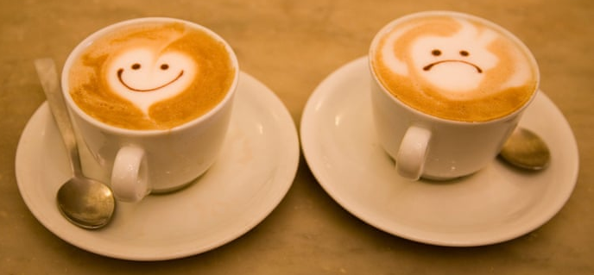

Sheree is now stocking a variety of Café Direct coffees
What makes Café Direct different?
The familiar Fairtrade logo certifies that farmers receive a fair and stable price which matches at least the basic costs of sustainable production. To cover basic costs may not seem such a big deal but, now that the global coffee industry is facing an unprecedented price crisis, for a coffee farmer it probably means the difference between feeding the family or going hungry.
So it is always important to look for the Fairtrade logo.
But it’s also worth remembering that not all brands have the same ethical or effectual credentials.
Café Direct came about as the innovative result of four pioneering organisations and three entrepreneurial grower cooperatives all seeking to bypass the conventional coffee market and find a better, more personal, direct way to trade.
Café Direct:
- still puts the producers directly at the heart of the business, working with all the growers directly without using middlemen
- never assumes it understands what's best for its partner organisations and cultivates long-term relationships with each of its producers, conducting face to face meetings each year with every farmer to understand the positive and negative impacts of its business
- has almost 90% of its farmers as shareholders
- invests 50% of its profits into Producers Direct, a UK charity run by farmers, for farmers, taking leadership and developing innovative solutions to the challenges they face
- is a top scoring brand with the Ethical Company Organisation which guarantees a clean record not only on Fairtrade, but also on a whole raft of human and animal welfare and environmental criteria
- is commended by Ethex uk for rainwater capture and reforestation programmes
- was named UK Social Enterprise of the Year for 2018
- partners small co-operatives such as Muungano in the DRC, which brings together members from previously conflicting ethnic communities, and Red de Mujeres , a network of women widowed or abandoned during the 36 years of civil war in Guatemala
- tops the list of coffees recommended for ethics and taste by the Good Trade international online ethics guide
- sells quality coffee which tastes good!
Organic Machu Picchu, rich and smooth with overtones of fine dark chocolate, is popular but some people prefer Kilimanjaro, bright & complex with a blackcurrant sweetness, and others choose the Smooth blend for anytime drinking.
“The current pauperization of coffee producers is destroying the very social fabric in the rural areas of more than 40 countries in Africa, Asia and Latin America, leading to increased criminality, more poverty in the cities, and massive migrations towards the United States and Europe. In some countries, the price crisis has become an incentive to shift to illegal crops because farmers cannot make a living from coffee alone.
Quality and availability are also threatened. Producers who stay in coffee will not be able to afford the proper care of their farms which will lead to improper fertilization and care of the trees, affecting the quality of the coffee and depriving consumers of the diversity they enjoy today.
Even if a coffee results in a great beverage, if it does so at the cost of the dignity, value or wellbeing of the people and the land involved, it cannot truly be a sustainable coffee.”
The Coordination Group of World Coffee Producers

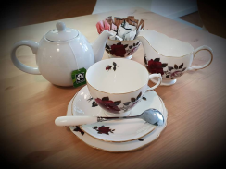
Sheree’s Store and Tearoom
supports Fairtrade

